HISTORY OF MEDICINE LECTURE
Center for Medical Humanities, Compassionate Care, and Bioethics

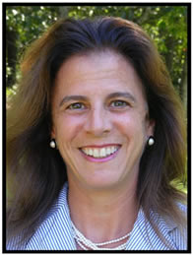

Dr. Lisa Lavine Nagy, M.D.,
Medical Director: Vineyard Personalized Medicine (Vineyard Haven, MA)

Thursday, October 18th, 4:00-5:00 PM, Lecture Hall 2

“What Really Causes Illness?: The role of Environmental Medicine in the Future of Health Care.”

Many diseases are considered “idiopathic” but more and more we are discovering their environmental triggers, as in the case of autoimmune and neurological diseases and mental illness. What are the effects of pesticides, chemicals and mold and food toxins on human health as our reliance on technology increases in our contemporary world? How much have we attributed to the environment in the past in terms of diagnosing illness? To what extent will identifying environmental causes of illness figure into the delivery of health care in the future?

All welcome. Admission free

http://stonybrook.edu/bioethics/historyofmedicine

