Center for Medical Humanities, Compassionate Care, and Bioethics
Stony Brook University Health Sciences Center
34th Annual History of Medicine Lecture Series

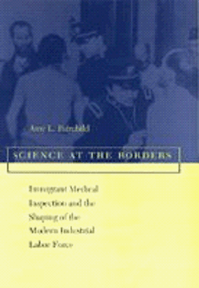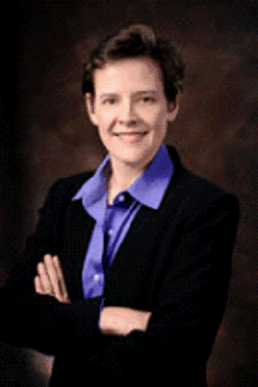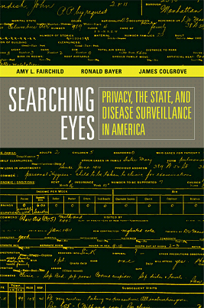

Amy Fairchild, PhD, MPH, Columbia University
Exodous of Public Health:
What History Can Teach Us About the Future
December 7, 2010
HSC Level 2, Lecture Hall 2
4:00-5:00 p.m.

